Entry Form

Name: _____________________________________

Club: _____________________________________

Division: _____________________________________
(A, B, C, + Junior Event – Open to all players)

Phone: _____________________________________

Email: _____________________________________

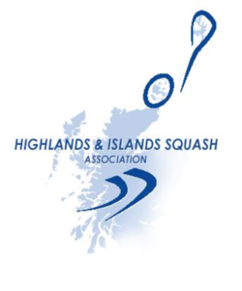
Venue: Thurso Squash, Tennis & Racketball
Club, Millbank Road, Thurso, KW14
8PS

Dates: 14th + 15th November, 2015

Contact: Garry McKay
T: 07890 878 611
E: garrymckay17@btinternet.com

Closing Date: Friday 6th November

Entry Fee: £10 (cheques payable to HISA)

Electronic Entries: garrymckay17@btinternet.com

Postal Entries: Garry McKay, c/o Inverness Tennis & Squash Club, Bishops Road, Inverness, IV3 5SB

